District Rocky Mountain held its spring meeting at the Anheuser Busch Brewery in Fort Collins on April 11th. Anders Nielsen, a student of the Brew Master program at the Scandinavian School of Brewing, spoke on the subject of “Brewery Student Beyond Borders.” Over 100 people attended the meeting and listened attentively to the story of Anders’ riveting journey through half a dozen different breweries.

As attendees arrived, Anheuser Busch employees took groups of people up to a conference room in the main building. It was a new venue for the group, and the spacious room with a bar on the side was quite conducive to a successful meeting. The meeting started off with a social hour, during which time it was possible to take a tour of the facility. A variety of new and old favorite A-B products were available for those who hung back in the room.

After the social hour, dinner was served in the meeting room. As the group was finishing eating, Gary Dick, district president, called a quick business meeting to order. He thanked Anheuser Busch for hosting our spring meeting. He then called on membership chair Dana Johnson for an update. Dana reported that we’ve met our district goal of 250 members, and he’s setting a new goal of 275, which he’d like to reach by the fall meeting in Golden.

Next, Finn Knudsen, the district technical chair, gave an update about the Technical Summit which will be held in Fort Collins at CSU on June 22nd. The Summit will be a full day of seven technical presentations on a wide variety of subject pertaining to technical brewing knowledge. Finn has already received commitments from multiple international attendees. Lunch, as well as a concluding happy hour at Odell Brewery, will be included in the cost of the summit. The district has arranged for discounted rooms for anyone interested in spending the night in Fort Collins. The summit already has many sponsors, which will make the cost very affordable to district members. Registration information will be available by April 22nd and will be emailed out to members and to regional breweries and brewing organizations.

After a quick update from scholarship chairman Jeff Biegert, Gary Dick announced that our treasurer Julie Glass had to step down to pursue schooling outside of the area. Jim Canary has agreed to rejoin the executive board in her place. Gary officially nominated Jim for the role of treasurer, the motion was seconded, and without objection, Jim Canary is now the new treasurer of the district.

Next, Finn Knudsen introduced the evening’s guest speaker, Anders Nielsen. Anders studied engineering and biotechnology at the Danish Technical University, graduating this past fall. While studying at university, he became the student project manager of DTU – Brew house, a student driven 200L scale brewing & innovation platform. He is currently interning at various breweries for six months, prior to starting his masters in engineering coupled together with the brew master education at the Scandinavian School of Brewing. He is in Colorado, interning at present with the Left Hand Brewery in Longmont.

Anders started his presentation off by describing his background and the various breweries he’s worked at so far. He described at length the extensive training that is part of the brew master program which has taken him on this circuitous journey. The first brewery he worked for was a 3 million hl/year brewery in Hamburg. He also worked for two weeks at a malting plant in Denmark. He now finds himself at Left Hand Brewery, a small craft brewery in America. The next place will be a microbrewery in Norway which is also the only brewery in Europe that brews sake.

Because of his decision to break his internship up into smaller opportunities at a variety of places, he was able to see a much wider picture of the brewing industry. At the larger breweries, he learned how an international company works, focusing on control, analysis, and uniform production. He learned the special considerations necessary when brewing on a large scale. At the smaller breweries, he learned about the art of brewing, their daily customer contact, and as he put it, “This is where you learn to brew beer. This is where you get your hands dirty.” Because he was able to see, smell, and feel the raw materials as he added them by hand, he had a much closer view of the process and a much better understanding for it.

Anders discussed ways that large and small breweries could stand to learn from each other. Big breweries have created great efficiencies, have more technical approaches to brewing, and have innovated in the areas of recycling, utility conservation, and waste disposal. Small breweries have a stronger customer focus, they are more involved with their raw materials and their process in general, and a stronger passion for what they do. Neither of these by themselves is as strong as a combination of the two approaches. He concluded by appealing to the brewers in the room to listen when interns or new brewers question the status quo, as it can be a great opportunity for improvement.

After the presentation, Anders was thanked for speaking with an engraved mug from the Rocky Mountain District. And as is customary, the evening concluded with a very lively raffle of prizes supplied by many of the members. The next meeting of District Rocky Mountain will be the Technical Summit in Fort Collins on June 22nd, 2012, followed by the summer meeting on August 8th at Rockyard Brewery in Castle Rock.

Tamar Banner
Publicity Chair
Master Brewers Association of the Americas - District Rocky Mountain
April 13, 2012

Attached photos:

Photo 1: Jim Canary and Paul Kuznia, serving beers during the happy hour.
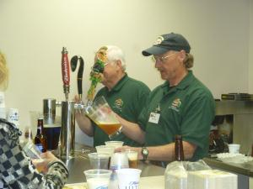
Photo 2: Jeff Biegert and Chad Hatlestad.
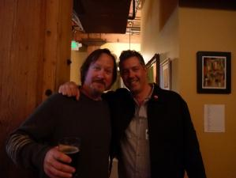

Photo 3: The cool kids, drinking beers in the back of the room: Colin Wescott, Chris McCombs, and Jason Trujillo.
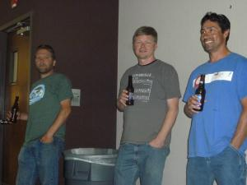

Photo 4: Finn Knudsen presenting Anders Nielsen with his mug.
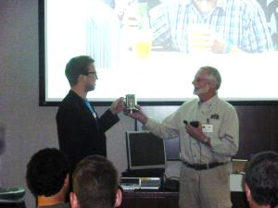
Photo 5: Perry Dickerson and Armando Calderon, trading tickets before the raffle, a time honored Rocky Mountain District tradition.
